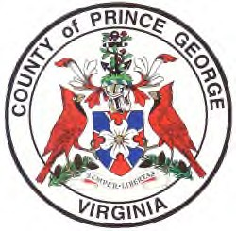
AGENDA

Prince George County Electoral Board Meeting
October 12, 2021, 2:00 PM
General Registrar’s Conference Room
2nd Floor Administration Building
6602 Courts Drive, Prince George County, Virginia

- Call to Order
- Pledge of Allegiance
- Adoption of Meeting Agenda
- Proof of Notice of Meeting
- Approval of Minutes
- Introductions/Public Comments
- Reports:
  - Electoral Board – September 21, 2021, Closed Session
  - VEBA President
  - Director of Elections & General Registrar Director
    - General Election-COVID Protocols/County’s Guidance
    - Logic & Accuracy Testing
    - Update - Early Voting Update
    - Update - Officers of Election Notification/Training
    - ELECT Communication/Advisory
- Unfinished Business
  - Delegation to General Registrar and Staff
  - Update - Remote Meetings Policy – Legal Review
  - Time/Location of future meetings – Post General Election Discussion
- New Business
  - Notice to Party Chairs – Absentee Vote Counting
- Adjournment
- Parking lot items for future meeting -Informational only
  - COVID
  - Information Assurance
  - Election Security
  - Training Academy for OEs

